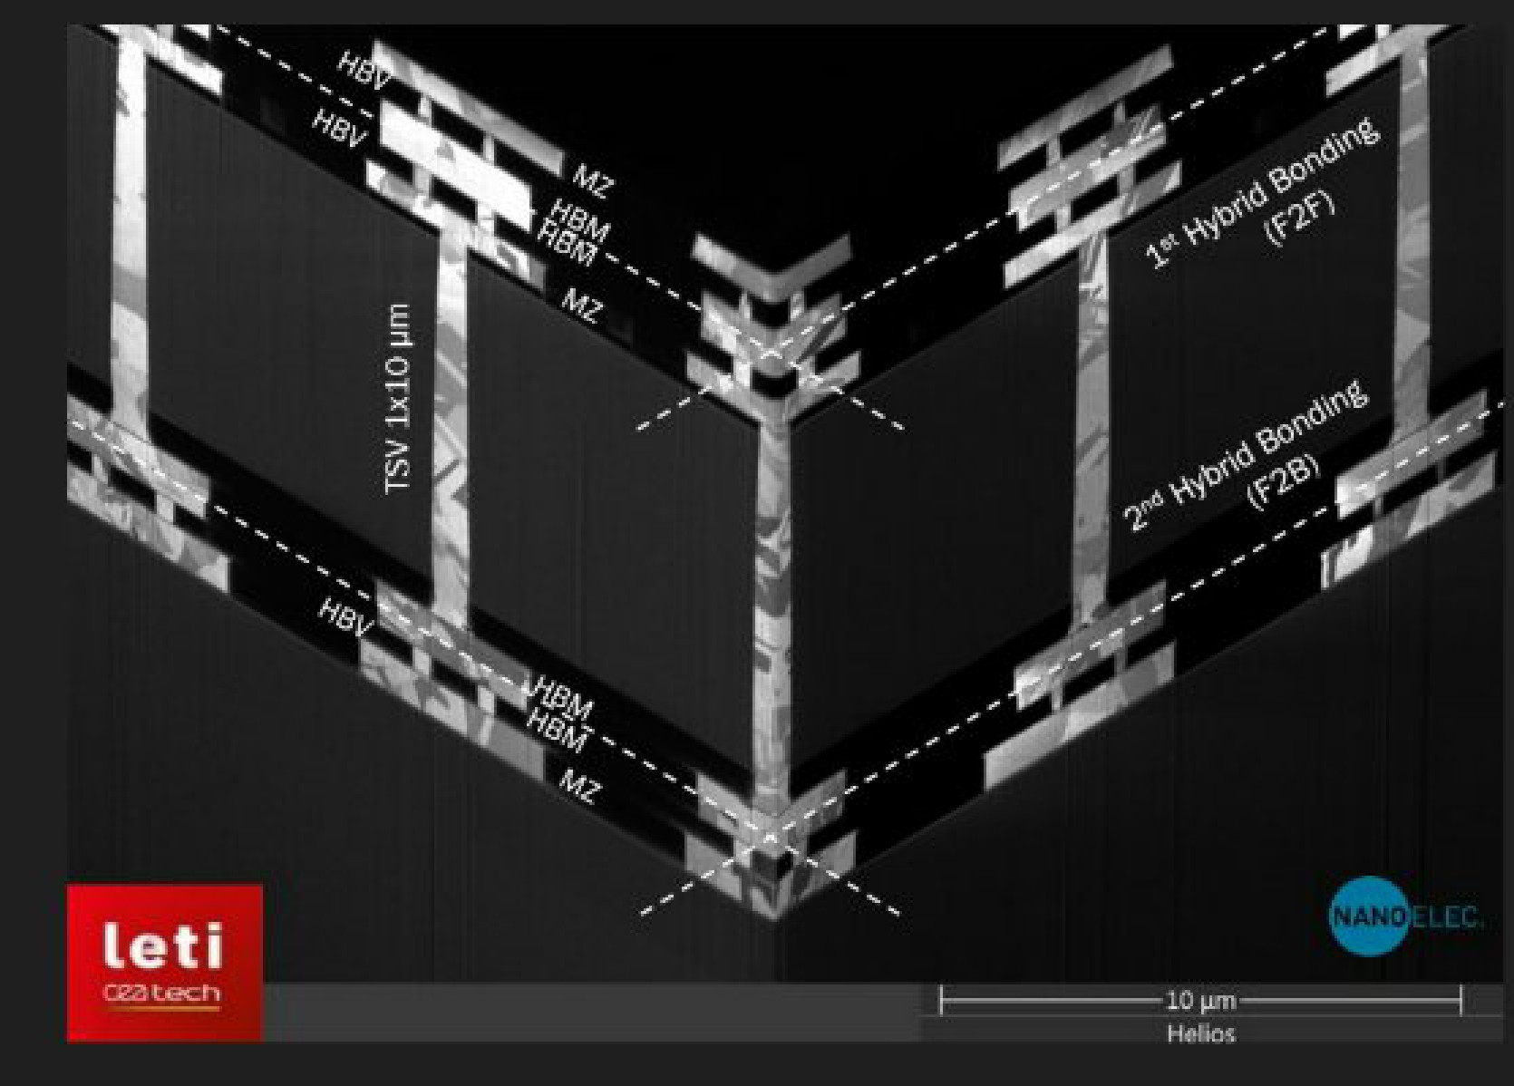

A Demonstration of a Hybrid Bonded 3D Architecture with Applications in CMOS Image Sensors: 3D integration, where multiple device layers are stacked vertically, enables the integration of multiple functions in a compact space, improving performance and reducing power consumption. Hybrid bonding (HB), also known as Cu-Cu direct bonding, provides a high-density, low-resistance interconnection between two bonded wafers.
Through-silicon vias (TSVs) also play a crucial role in 3D integration by providing a pathway for efficient signal transfer and power distribution between the vertically stacked layers. For CMOS image sensors, combining hybrid bonding with high-density TSV arrays could facilitate the integration of various functionalities with unparalleled precision and compactness, such as image sensor arrays, signal processing circuits, and memory elements.

Researchers from CEA-Leti will describe various test vehicles they built to explore this approach, ultimately resulting in a three-layer demonstrator (shown above) with both standard pitch (6 µm) and fine pitch (4 µm) and with two Cu-Cu hybrid bonding interfaces (one face-to-face and one face-to-back) combined with high-density TSVs (10 µm height, 1 µm diameter). After fabrication, characterizations of the structures (FIB-SEM
cross-sections) verified that the entire 3D stacked structure had good metal connection at the HB and TSV interfaces. For electrical characterization, different types of Kelvin and Daisy Chain structures were tested. The results for the Kelvin structures showed a median resistance of just a few ohms, and a >80% yield. Those results were confirmed by electrical measurements on the Daisy Chain structures. The researchers say that after this demonstration of three-layer functionality, the next step will be to implement the 3D technology in a functional advanced CMOS image sensor.

(Paper #8.2, "3-layer Fine Pitch Cu-Cu Hybrid Bonding Demonstrator With High Density TSV For Advanced CMOS Image Sensor Applications," S. Nicolas et al, Grenoble Alps Univ./CEA-Leti)

